A575-US-ME-Magalloway River Valley-Debert Fluted Spear Point-10,000 BP

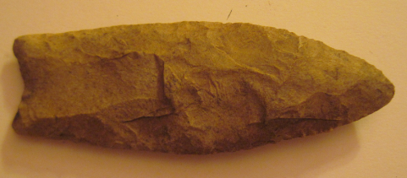

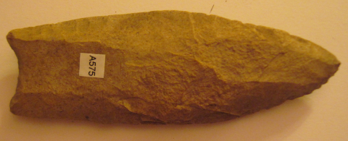

This fluted spear point of yellow-brown chert was discovered in the spring of 1978 along the Little Magalloway River. It has a relatively shallow basal flute and the edges are sharp but probably not retouched or resharpened. This spear point is similar to examples from the Debert Site in Nova Scotia. The balance is anterior to the longer flute at the maximum width of the point. The source of the yellow-brown chert or jasper is unknown.

   by Pete Bostrom

   Debert "fluted" points were named by George F. McDonald in 1968 for examples found on the Debert site in central Nova Scotia. These deeply concave base points are found mainly in Nova Scotia and Maine. Many of the fluted points found on the Vail site are classic examples of Debert points. The bases with long delicate "ears" are similar to bases on many Dalton points.

 This Debert/Clovis point, number V.5581, measures 3 7/8 inches long.



Case no.:

Accession Number:

Formal Label:

Display Description:

LC Classification:

Date or Time Horizon:

Geographical Area:

Map:

GPS coordinates:

Cultural Affiliation:

Media:

Dimensions:

Weight:

Condition:

Provenance:

Discussion: